**For Mobile:**

**Step1:** Open EYE+ Salesbuddy App.

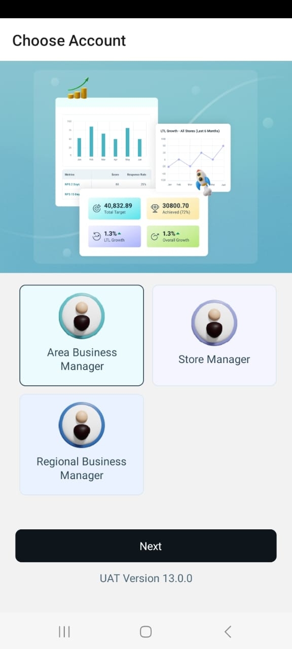**Step2:** Select your respective persona **ABM** or **RBM** and click on “Next”button.

Select your persona

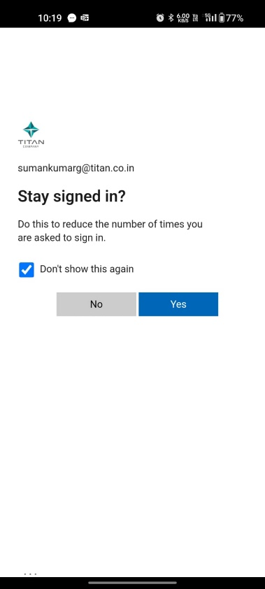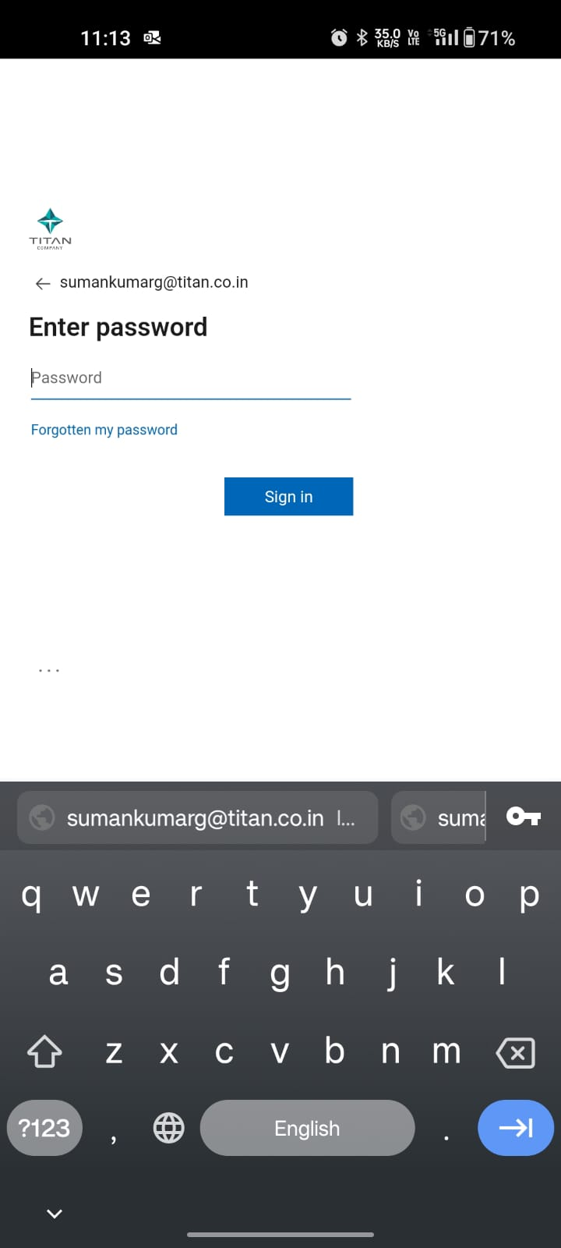**Step3:** Enter your **Titan Domain ID/Password** and click on **Yes**.



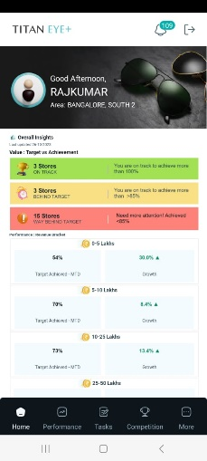**Step4:** You will be automatically redirected to the landing page.

